**Generating a new SSH key and adding it to the ssh-agent**

1. Open Git Bash Shell in the Project Folder run below command

ssh-keygen -t rsa -b 4096 -C "sachinsabale099@gmail.com"

1. Open PowerShell with run as Administrator privilege and run below commands

Get-Service -Name ssh-agent | Set-Service -StartupType Manual

Start-Service ssh-agent

1. Run the below commands in the Git Bashshell

eval "$(ssh-agent -s)"

ssh-add /c/Users/Administrator/.ssh/id_rsa

cat /c/Users/Administrator/.ssh/id_rsa.pub

1. copy the public key and open Gitlab in the web browser and logged in. Navigate

( settings/ssh/new SSH Key )

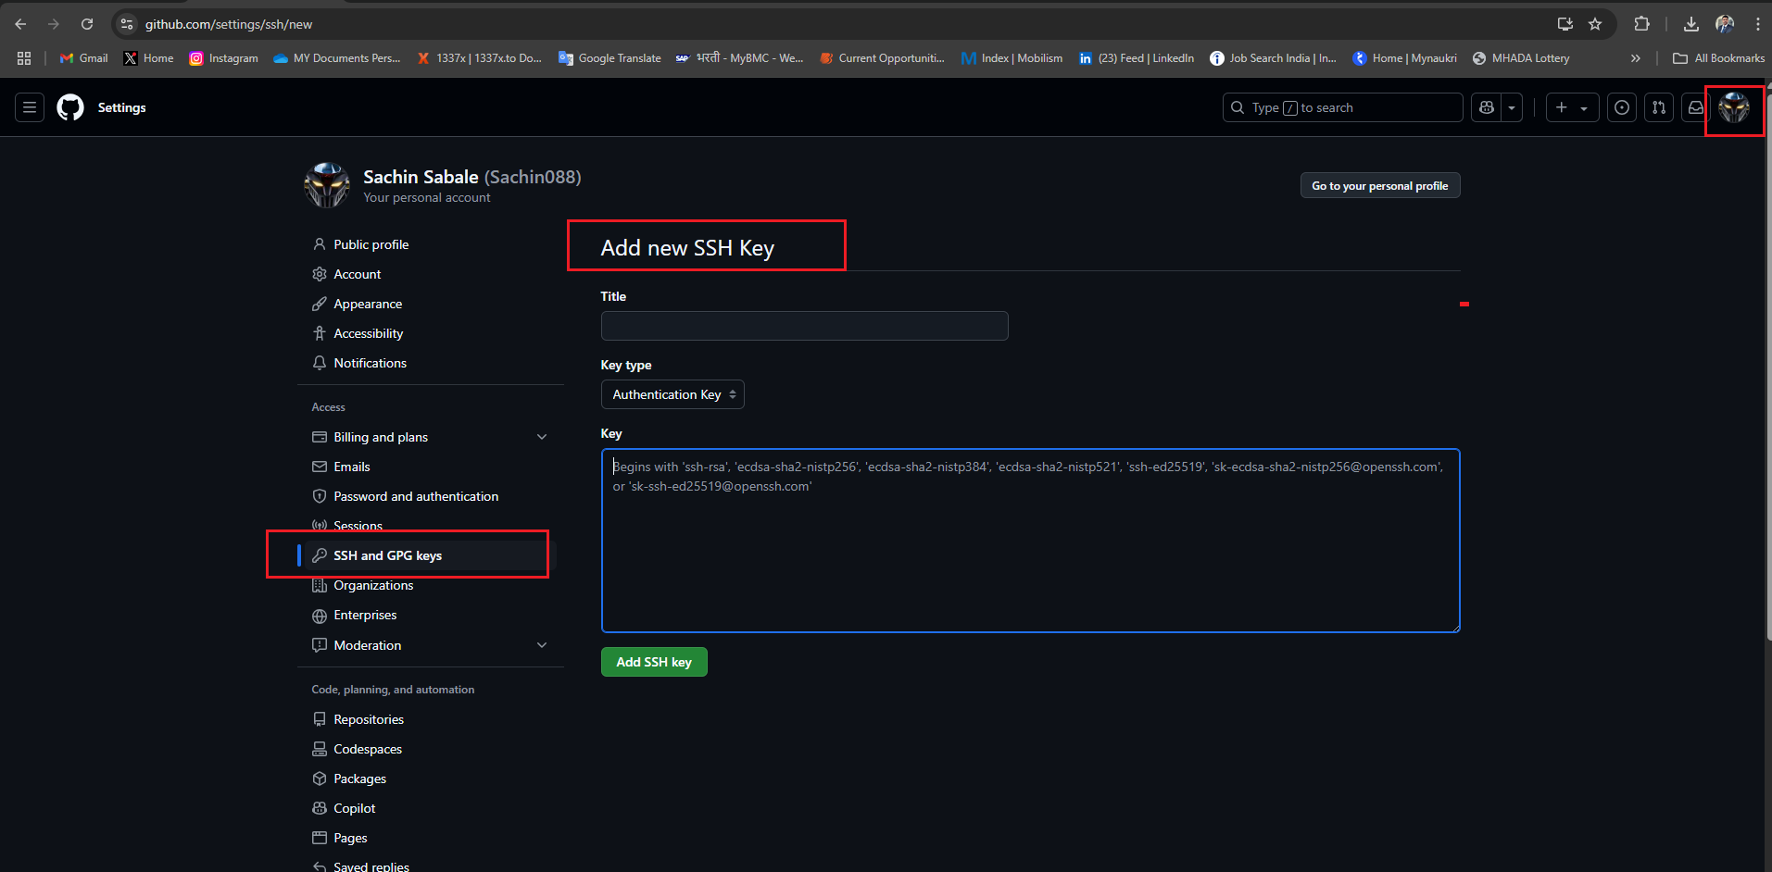

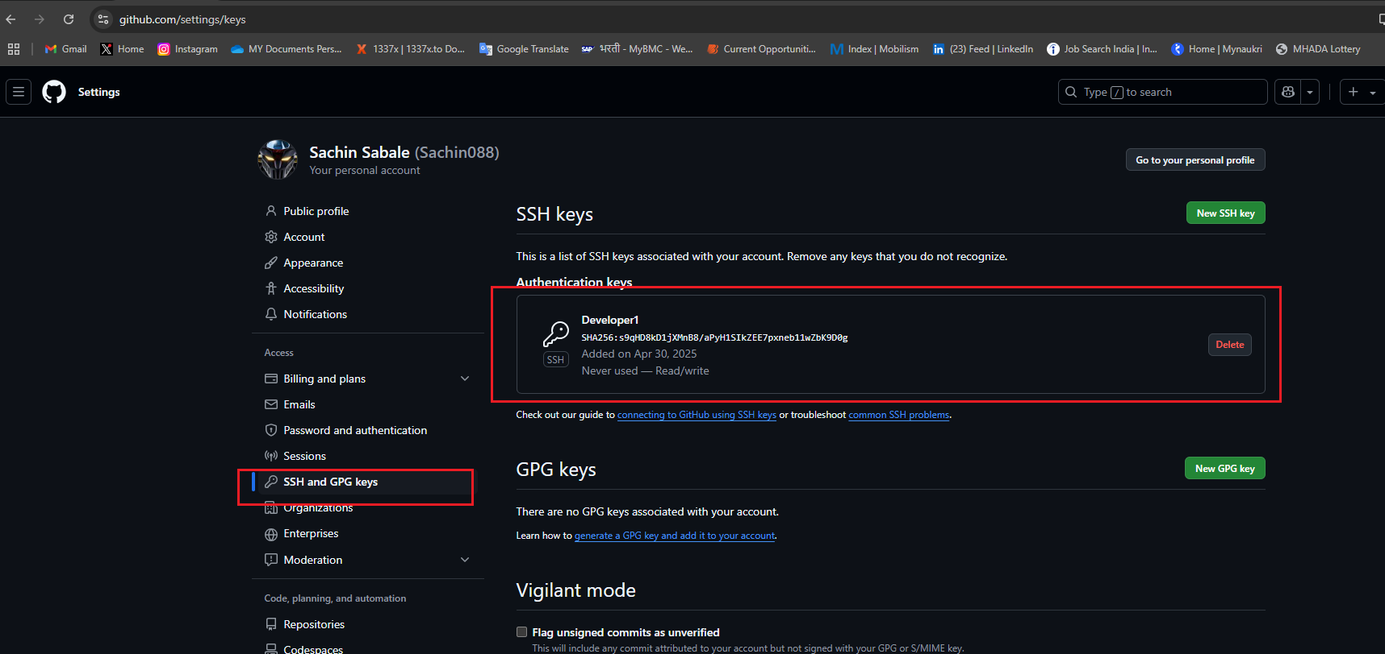

git clone git@github.com:Sachin088/Developer1-LocalRepo.git

git config --global User.Name "Developer1"

git config --global User.Email "sachinsabale099@gmail.com"

git config --list